Hello everyone
I cannot believe this is the week we get our summer holidays!
I have really enjoyed having you all in class this year. We had great fun. Well done to everyone for all your hard work the last few months.
Have a lovely summer. I look forward to seeing you all in September.
Ms Tansey

Some fun stuff

English
Activity 1 Boggle (attached in email)
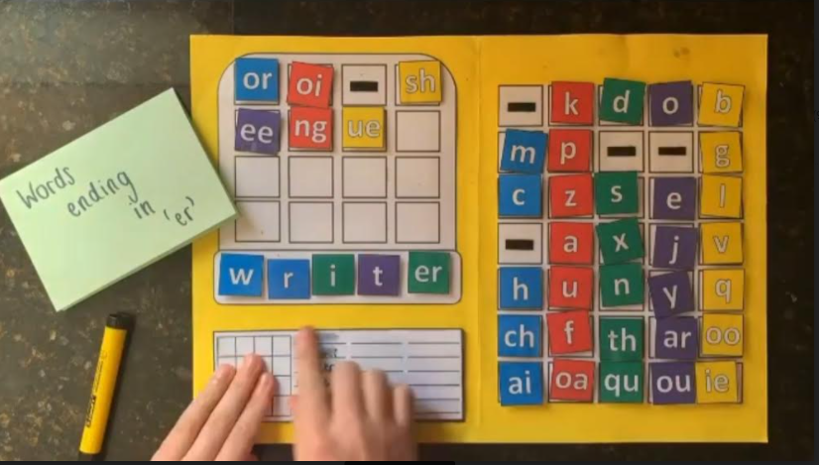
You can use this individually to make words or play as a game with family. (3 letters=3 points, 4 letters =4 points etc) or make up your own rules.

Activity 2
Stop the bus
This is a great game to revise vocabulary
Procedure
- Draw a table like the ones below
- Students simply have to think of one item to go in each category beginning with the set letter.
- Give an example line of answers for the first time you play with a new group.
- The first Person to finish shouts 'Stop the Bus!'.
- Check their answers and write them up on the board and if they are all okay that person wins a point. If there are any mistakes in their words, let the game continue for another few minutes.
- If it gets too difficult with certain letters (and you can’t think of one for each category) reduce the amount of words they have to get. You can say, 'OK, for this round you can Stop the Bus with four columns.'
 | animals | colours | food | clothes | countries | sports
T | tiger | turquoise | tuna | trousers | Tunisia | tennis
For higher levels change the category headings. For example:
 | something in the Kitchen | something in the living room | something in the bedroom | something in the bathroom | something in the office | something in the garden
S | spices | sofa | sheet | soap | staples | seat
Or, for even higher levels:
 | something made of metal | something made of glass | something made of plastic | something made of wood | something made of material
B | bike | bottle | bin | bench | belt

Gaeilge
https://www.leighanois.com/ (nice website with picture books)

Maths
3rd class p 173-176 Busy at Maths
4th class p172-176 Busy at Maths
5th class figure it out 5 p89-92

Maths Games online http://toytheater.com/

STEM challenge

PRINGLES RING STEM CHALLENGE

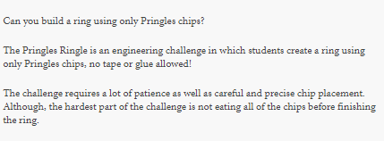

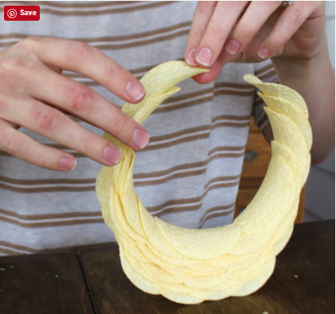

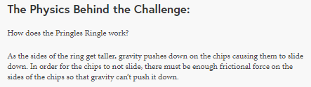
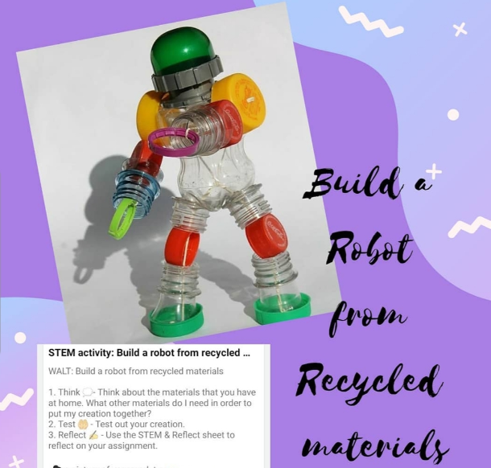

Design and make activities (attached in email)

Virtual tours
Dublin zoo
https://www.dublinzoo.ie/virtual-tours-2/

ÁRAS AN UACHTARÁIN
https://president.ie/en/childrens-section
National History Museum
https://www.museum.ie/en-IE/Museums/Natural-History/Visitor-Information/3D-Virtual-Visit
https://www.cliste.ie/natural-history-museum-virtual-tour/

