Hello everyone. I hope you are all well and are enjoying the sunshine. Please find attached some work for the week 5th-8th May. These are just suggestions. There are lots of ways to learn and some of you might be baking, gardening, farming, footing turf, cleaning and helping out at home … this is all learning too! Do what you can and please don’t hesitate to send me an email if you have any questions.
Looking forward to hearing from you soon. Ms Tansey
Tanya.tansey3@gmail.com

English
List 29 spellings made fun
Please find attached a reading passage for 3rd (Mr Stink) and 4th (Matilda).
Read the passage and answer the questions in your copy.
Idioms I have attached 3 sets of idioms all related to animals. Pick 4 of your favourite and put them into sentences of your own.

Maths (I have attached some PowerPoints and charts to help)
3D shapes
3rd chapter 21 Busy at Maths 3 p115-118
4th chapter 19 Busy at Maths 4 p96-99
5th chapter 16 figure it out 5 p53-55

Maths game can you get closest to 100?
you will need dice, paper and pen/ pencil
Take it in turns to roll 2 dice and add the numbers together. Add this number to your score each time until you get as close to 100 as possible.

Gaeilge
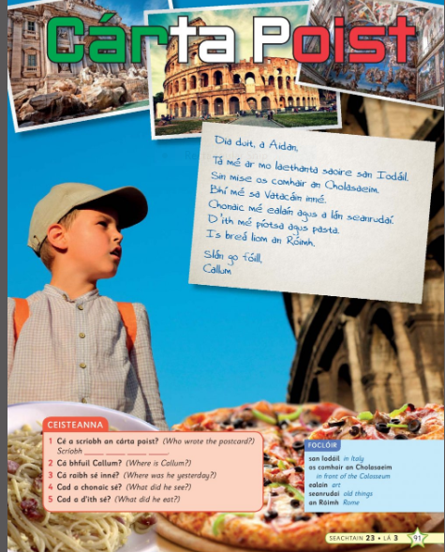
Audio Link http://data.cjfallon.ie/audio/LeighsaBhaile-C-p91.mp3
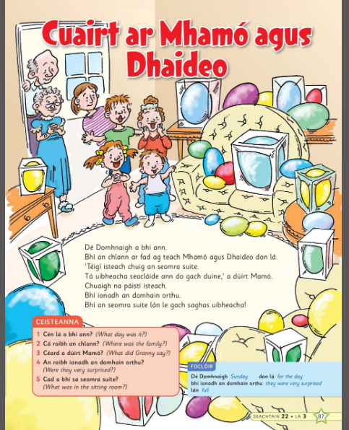

Audio Link http://data.cjfallon.ie/audio/LeighsaBhaile-C-p87.mp3
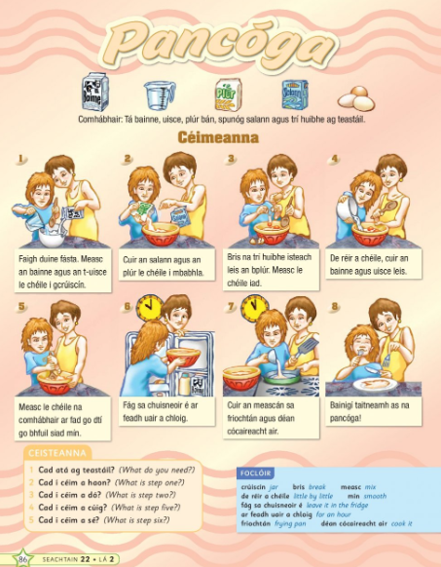

Audio link http://data.cjfallon.ie/audio/LeighsaBhaile-C-p86.mp3

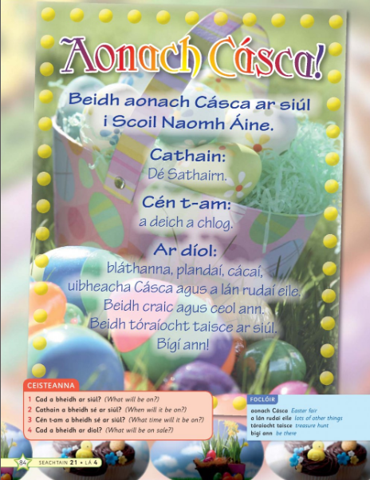

Audio Link http://data.cjfallon.ie/audio/LeighsaBhaile-C-p84.mp3
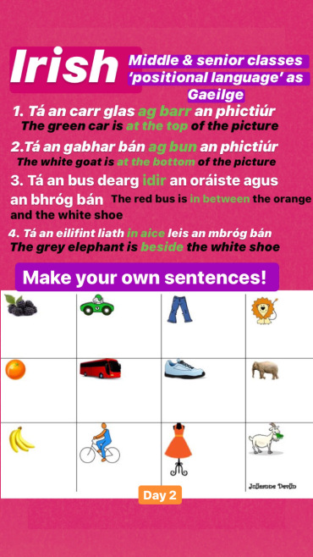

Geography
Colour by number counties of Ireland (see attachment)
Countries of Europe (See attachment)

History
The story of The Pyramid
https://my.cjfallon.ie/preview/student/1415/46

Art
The following is a link to an art competition if you would like to enter or if not even just to practice drawing some pop art yourself
https://www.marine.ie/Home/site-area/areas-activity/education-outreach/explorers-pop-art-and-creative-writing-competition?language=en

Typing skills
Here is a really nice website with activities to help you become better and faster at typing
https://www.bbc.co.uk/bitesize/topics/zf2f9j6/articles/z3c6tfr

Scroll down

Fun
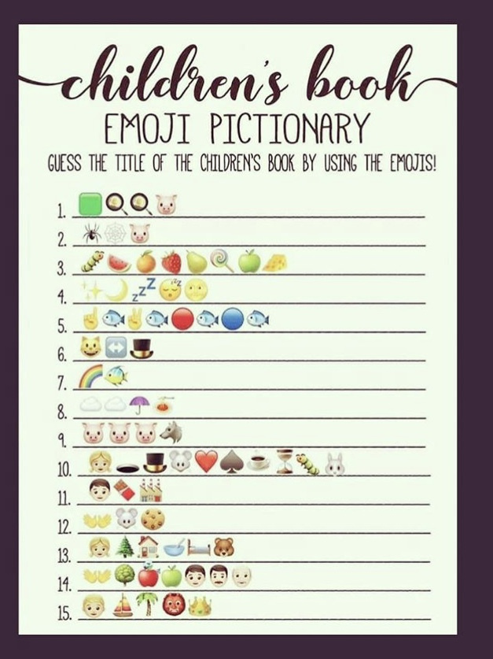
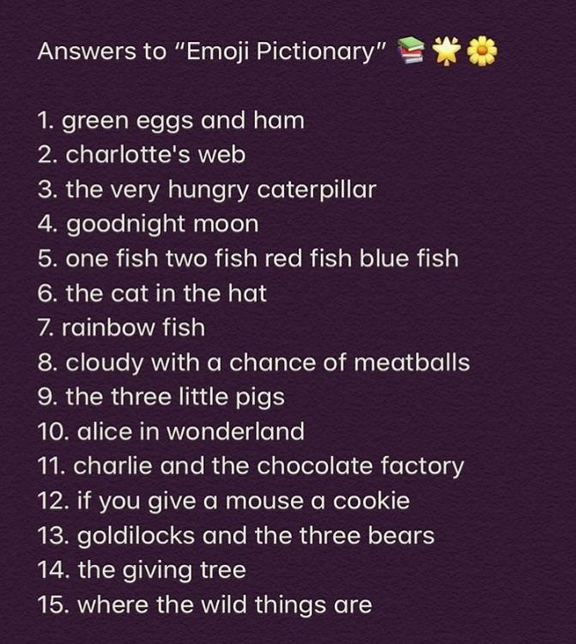

RTE school Hub
On RTE school hub this week for 3rd and 4th will be
Tuesday | Art | Dreamcatchers
Wednesday | Gaeilge | Teilifís
Thursday | English | Procedural writing
Friday | Geography | Counties of Ireland (Connacht)

PE
-Youtube P.E. with Joe Wicks
-The 10 at 10 exercises are available on RTE junior
-Yoga for kids https://www.youtube.com/user/CosmicKidsYoga
-Go Noodle https://family.gonoodle.com/
-Music – Go to the Dabbledoo music website and enrol for free or follow the link below
https://dabbledoomusic.com/p/parents

