Hello everyone I hope you are keeping well. Please find attached some work for the week 18th-22nd May. These are just suggestions. Do what you can and please don’t hesitate to send me an email if you have any questions.
Looking forward to hearing from you soon. Ms Tansey
Tanya.tansey3@gmail.com

English
- List 31 spellings made fun
Reading Zone:
If you don’t have your book at home it can be found at:
- Go to www.folensonline.ie and tap Register
- Select Teacher
- Fill in a username, email and password
- For Roll Number use the code: Prim20
- Click Register
- Type in The Talking Horse (3rd class) or The Golden Harp (4th class) into the search bar

- 3rd class Unit 24 ‘’The Scarlet Rose’’
Use you Dictionary to look up words in red that you are unsure of
Complete activities A-G based on the chapter (Do what you can)

- 4th class Unit 24 ‘’The Golden Harp’’
- Use you Dictionary to look up words in red that you are unsure of
Complete activities A-G based on the chapter (Do what you can)

Irish
Bun go barr chapter 14 Mamaí Bhocht 86,87,88,89,90,91
- Unit 14 Mamaí Bhocht (Poor mammy) If you don’t have your book it can be found online at https://my.cjfallon.ie/dashboard/student-resources 3rd class Bun go Barr Online Book

- What was mammy doing? Bhí…
- What were the children doing? Bhí
- What did Mammy hear? Chuala Mamaí…
- Who started crying? Thosaigh…
- Did the children hear mammy calling? Níor…
- Who was at the door? Bhí…
- Who was on the telephone? Bhí
- Did the children hear mammy? Níor…
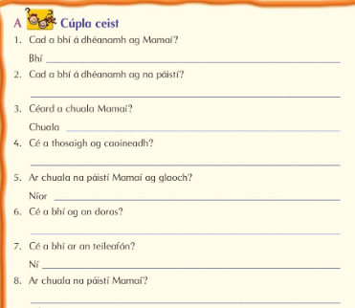

Daddy and the children are in the sitting room. There are flowers on the table. The telephone is on the table too. Daddy is talking on the telephone. There is a picture on the wall. The tv is on. Rossa is looking at the television. His ankle is broken. Neasa is drinking a cup of tea. Séimí is wearing a nappy. Séimí is crying but Cliona is laughing. There is a bin in the sitting room too. There is a clock on the wall. It is 7 o’clock.

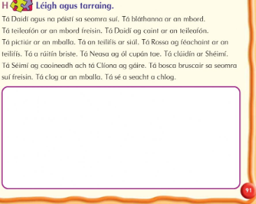

Maths (please find link attached in email fraction and decimal number line)
https://www.visnos.com/demos/fraction-wall
3rd class Busy at Maths 3 p110-114 Decimals
https://my.cjfallon.ie/dashboard/student-resources ( in the boxes found when you arrive on this page click primary, 3rd class, maths, busy at maths, busy at maths 3 and underneath then you should see the tutorials)
Tutorials 63 and 63

4th class Busy at Maths 4 p59-63
https://my.cjfallon.ie/dashboard/student-resources ( in the boxes found when you arrive on this page click primary, 3rd class, maths, busy at maths, busy at maths 3 and underneath then you should see the tutorials)
Tutorial 42,43,44 and 45

5th class
Figure it out 5 p29-33 https://my.cjfallon.ie/preview/student/1312/33
Figure it out 5 p34-38 https://my.cjfallon.ie/preview/student/1312/38

Geography
Lakes of Ireland (Link attached)
Counties of Ireland colouring crests (Link attached)
Waterways
https://learning.waterwaysireland.org/Resources%20Assets/Lucas%20and%20Lottie%20Exhibition%20Final.pdf

https://www.rte.ie/learn/2020/0331/1127539-3rd-and-4th-class-geography-waterways/
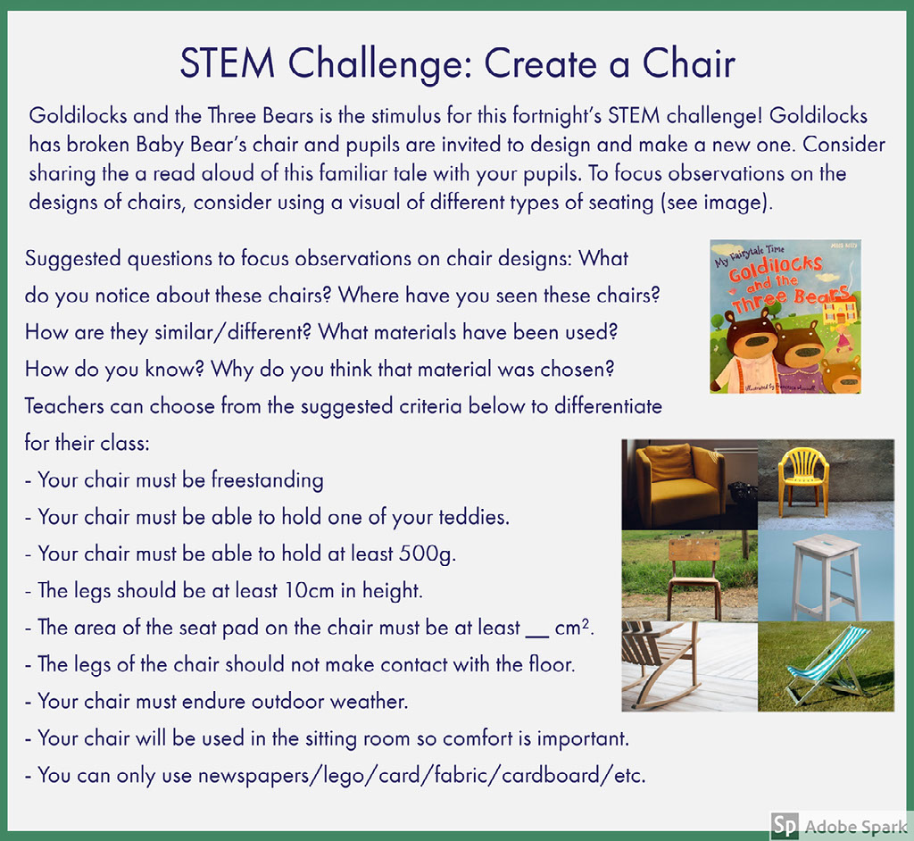

Nature walk leaves and twigs
https://www.woodlandtrust.org.uk/media/48345/leaf-id-sheet.pdf
https://www.woodlandtrust.org.uk/media/48347/twig-id-sheet.pdf

Minibeast detective
https://www.wildlifewatch.org.uk/images/Downloads/spotters/minibeasts%20v2%20small.pdf

Experiments
How to make a Volcano http://www.sciencefun.org/kidszone/experiments/how-to-make-a-volcano/
Lava Lamp http://www.sciencefun.org/kidszone/experiments/lava-lamp/

Art
Design you own GAA jersey (Link attached)
PE
-Youtube P.E. with Joe Wicks
-The 10 at 10 exercises are available on RTE junior
-Yoga for kids https://www.youtube.com/user/CosmicKidsYoga
-Go Noodle https://family.gonoodle.com/
-Music – Go to the Dabbledoo music website and enrol for free or follow the link below
https://dabbledoomusic.com/p/parents

