Hello everyone
I hope you are all well. It is hard to believe it is week 3 in June already. Please find attached work for the week 15th-19th June. These are just suggestions. Do what you can and please don’t hesitate to send me an email if you have any questions. Please email me some of your work that you are really happy with this week. I would love to see it. Thanks to those who sent me work last week.

Looking forward to hearing from you soon. Ms Tansey
tanya.tansey3@gmail.com

Happy birthday to Conor and Sinéad who will be 10 on Tuesday.

English
- We love riddles in 3rd and 4th class. I have attached some for you to have a try. (in email)

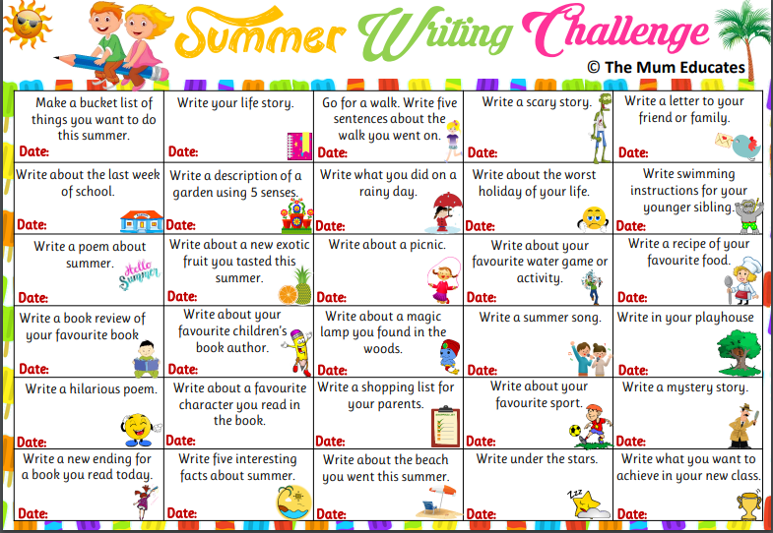
Maths
3rd class Chapter 28 p147-150
Chapter 26 p 137- 143
https://my.cjfallon.ie/dashboard/student-resources ( in the boxes found when you arrive on this page click primary, 3rd class, maths, busy at maths, busy at maths 3 and underneath then you should see the tutorials)
Tutorials chapter 28 (92 & 93)
Chapter 26 (85,86,87,88,89)

4th class chapter 24 p 122-124
Chapter 30 p147-152
https://my.cjfallon.ie/dashboard/student-resources ( in the boxes found when you arrive on this page click primary, 4th class, maths, busy at maths, busy at maths 4 and underneath then you should see the tutorials)
Tutorials Chapter 24 (87)
Chapter 30 (100)

5th class
Busy at Maths 5 https://my.cjfallon.ie/preview/student/16884/3 p89-93

Maths puzzles https://www.solvemoji.com/

Gaeilge

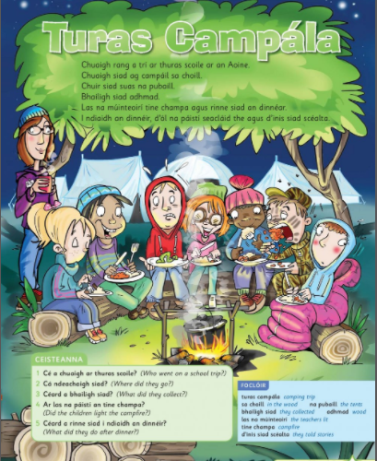

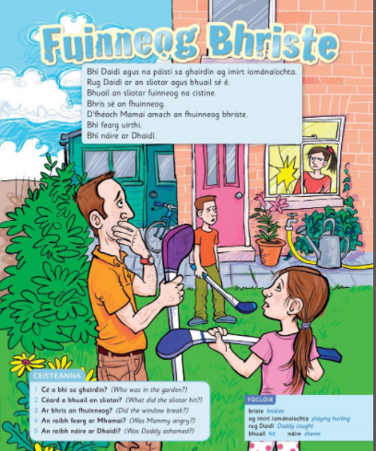

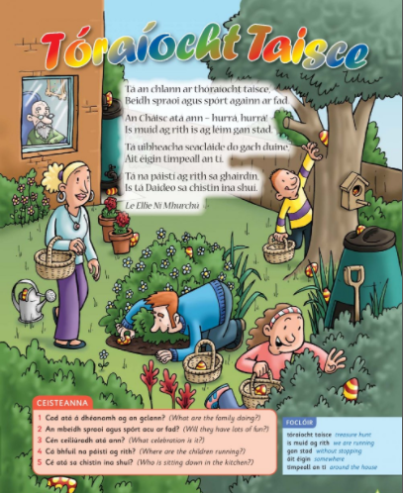

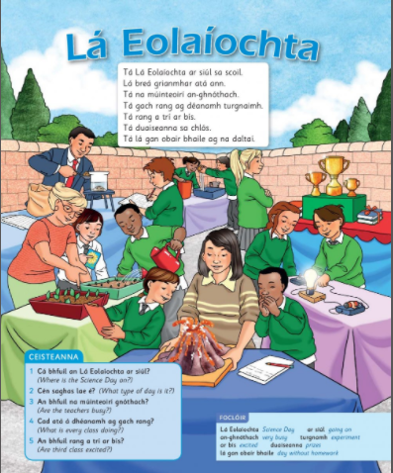

SESE
History Quest 3

https://my.cjfallon.ie/preview/student/1415/1 pg 60-66

Primary Planet:
The Primary Planet has some nice quizzes and activities
https://www.theprimaryplanet.ie/

Art

Paint or draw and colour a picture of sunflowers with whatever materials you have at home

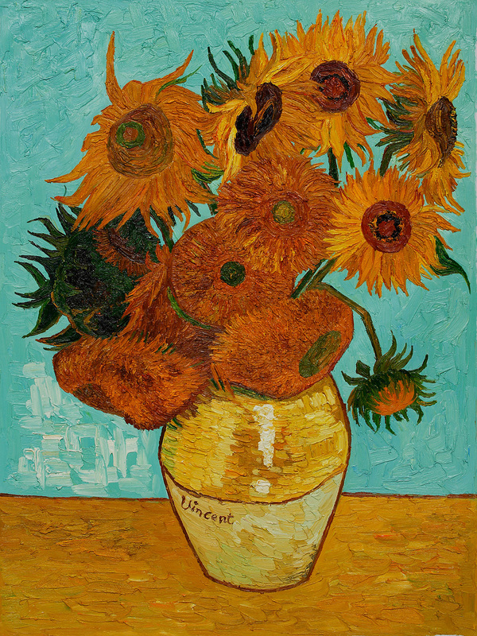

VAN GOGH, "SUNFLOWERS"
Vincent van Gogh was born in Holland in 1853 and died in France in 1890. He may not have always been very happy in his life, but his paintings are so bright and beautiful that he is now considered one of the most famous artists there ever was. Van Gogh did not start out to be an artist, but tried many different occupations first, including selling art, working in a bookstore, and being a preacher. He did not do a very good job at any of these things, so he finally decided that he wanted to be an artist.

Van Gogh liked to paint sunflowers because he thought they were very sunny and happy. He tried to sell them very cheaply to his friends to brighten up their walls in their homes, but no one wanted them. People didn't understand van Gogh's art during his lifetime, and they didn't like how the colours were so vibrant and the lines made them seem to come alive. In fact, van Gogh was very poor because he only ever sold one painting in his lifetime. Usually his brother had to send him money to help him buy food and art supplies. Van Gogh would rather paint than eat, so sometimes he would buy new colours rather than food.

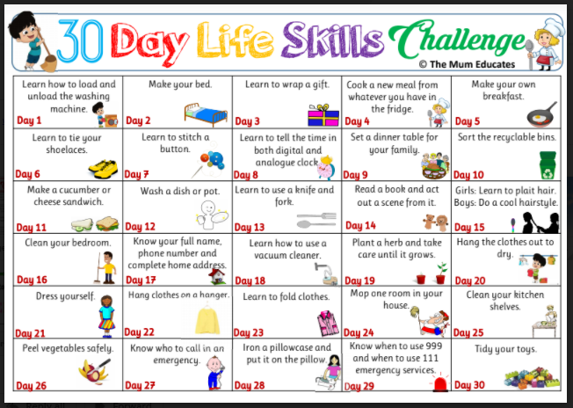
NB Day 28 parental supervision required

