Hello everyone
I hope you are all well and getting plenty of fresh air. Please find attached work for the week 8th-12th June. These are just suggestions. Do what you can and please don’t hesitate to send me an email if you have any questions. Please email me some of your work that you are really happy with this week. I would love to see it.

Looking forward to hearing from you soon. Ms Tansey
Tanya.tansey3@gmail.com

English
Reading Zone:
If you don’t have your book at home it can be found at:
- Go to www.folensonline.ie and tap Register
- Select Teacher
- Fill in a username, email and password
- For Roll Number use the code: Prim20
- Click Register
- Type in The Talking Horse (3rd class) or The Golden Harp (4th class) into the search bar

- 3rd class Unit 28 ‘’Clever Rosa’’
Use you Dictionary to look up words in red that you will find throughout the story (that you are unsure of)
Complete activities A-G based on the chapter (Do what you can)

- 4th class Unit 28 ‘’Seán Mac ’’Sharry climbs over the clouds
- Use you Dictionary to look up words in red that you will find throughout the story (that you are unsure of)
- Complete activities A-G based on the chapter (Do what you can)

- Third class comprehension The Diary of a killer cat (attached in email)
- Fourth class comprehension (attached in email)
Gaeilge
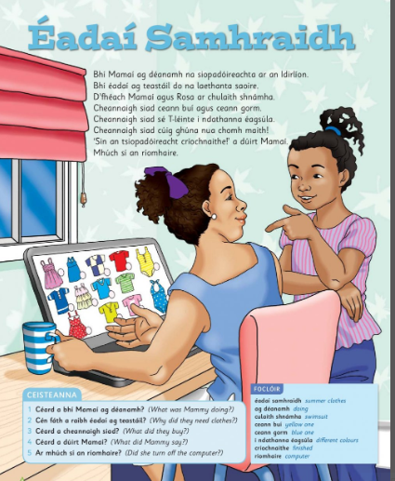

Audio link http://data.cjfallon.ie/audio/LeighsaBhaile-C-p112.mp3

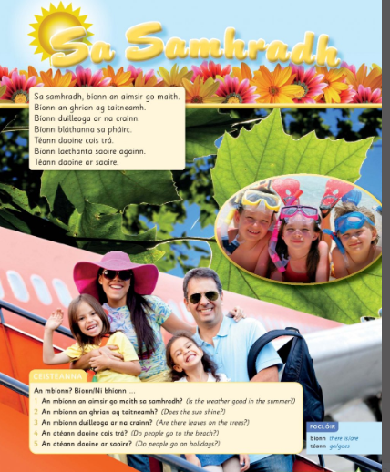

Audio link http://data.cjfallon.ie/audio/LeighsaBhaile-C-p113.mp3
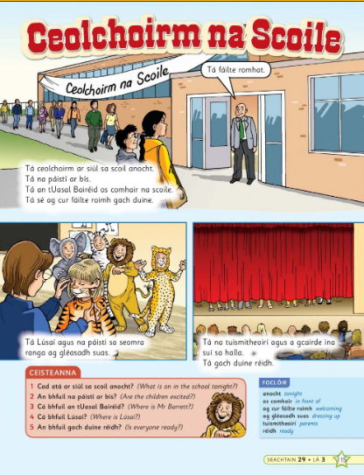
Audio Link http://data.cjfallon.ie/audio/LeighsaBhaile-C-p115.mp3
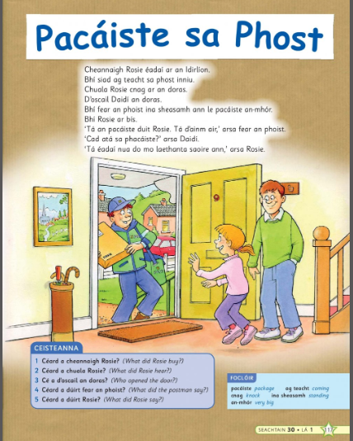
Audio link http://data.cjfallon.ie/audio/LeighsaBhaile-C-p117.mp3

Maths
3rd class chapter 32 capacity p 165-168
https://my.cjfallon.ie/dashboard/student-resources ( in the boxes found when you arrive on this page click primary, 3rd class, maths, busy at maths, busy at maths 3 and underneath then you should see the tutorials)
Tutorials 103,104,105,106

4th class chapter 33 p 163-167
https://my.cjfallon.ie/dashboard/student-resources ( in the boxes found when you arrive on this page click primary, 4th class, maths, busy at maths, busy at maths 4 and underneath then you should see the tutorials)
Tutorials 107,108,109

5th class capacity
Figure it out 5 https://my.cjfallon.ie/preview/student/1312/87 p83-85
Busy at Maths 5 https://my.cjfallon.ie/preview/student/16884/178 p170-175

Sudoku challenges (attached in email)

Sports star fact file (link attached)

The Primary Planet
https://newsmagmedia.ie/Previews.aspx
Here you will find lots of issues of the primary planet with some nice activities for children.

Geography
Greece fact file (Link attached)
Poland fact file (link attached)

Science

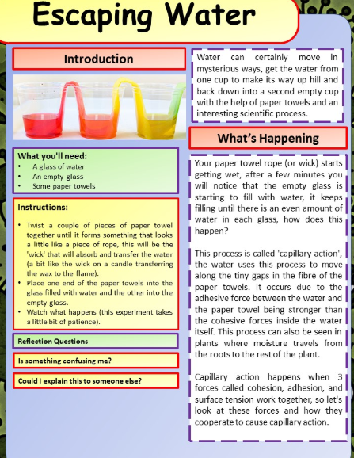
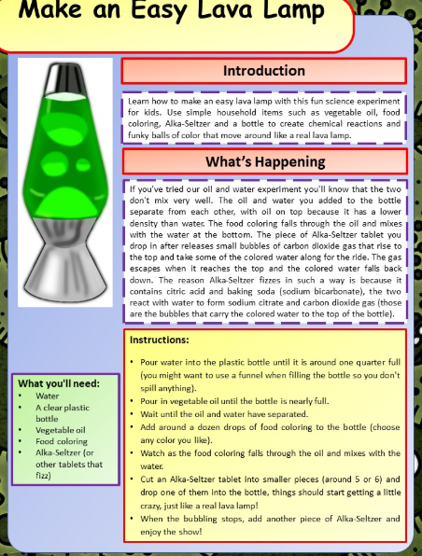

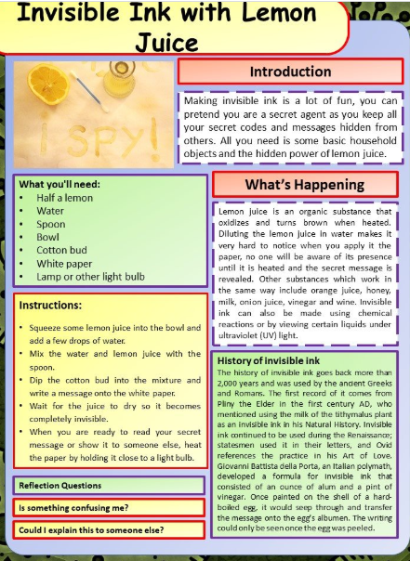

Virtual sports day
As we are getting nearer the end of term we know that sport day is one of those days that children enjoy.
So below is a list of equipment that can be adapted using things you have in your home already to have you own sports day at home.
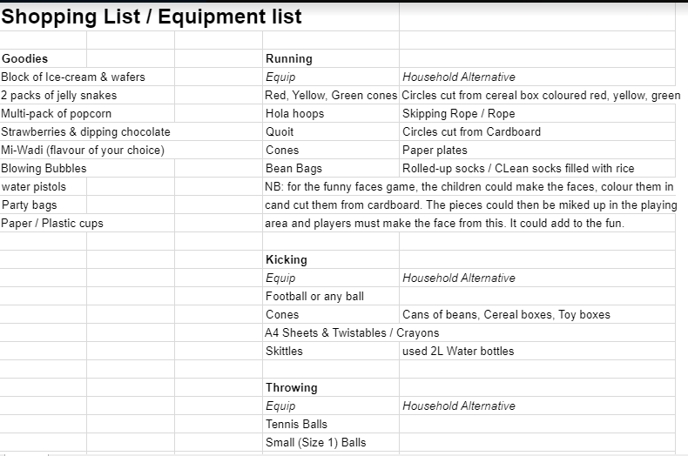
Music
You can use your own music or there is a sports day playlist if you have a Spotify account where all the music is all ready to go on a playlist.

Throwing
Activity 1
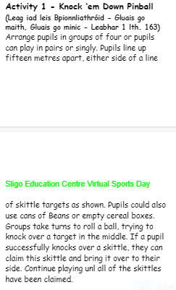
https://www.youtube.com/watch?time_continue=1&v=_BwUf9mXm4Y&feature=emb_logo

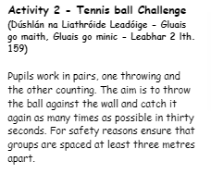
https://www.youtube.com/watch?v=KxD8V6xvsLk&feature=emb_logo

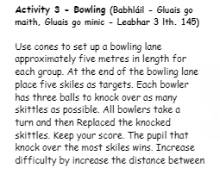
https://www.youtube.com/watch?time_continue=10&v=cg9gURRP63c&feature=emb_logo

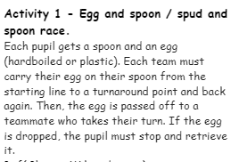
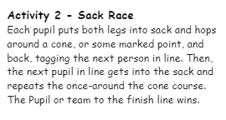

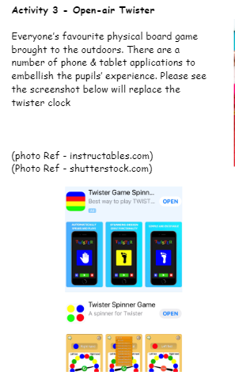

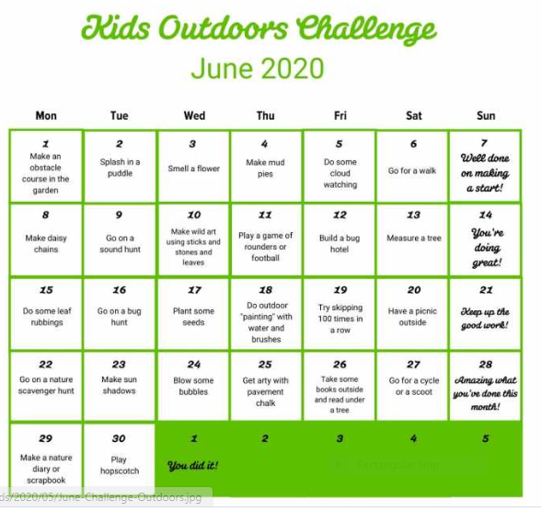
RTE school hub this week
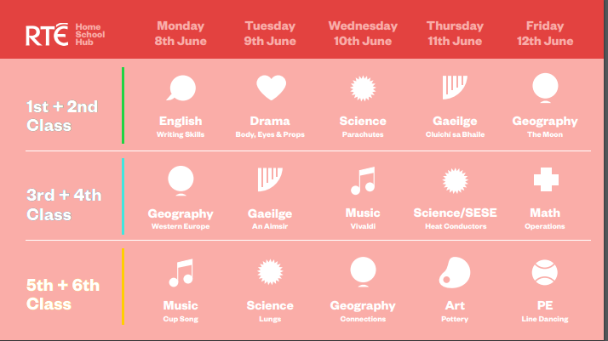
Fun

