Hello everyone

We had such nice weather this week. I hope you all got to go out and enjoy it. I hope you all managed to get some sunflowers. I can’t wait to see them grow. Please find attached work for the week Tuesday 2nd June- Friday 5th June. These are just suggestions. Do what you can and please don’t hesitate to send me an email if you have any questions. As weather is so nice lately I am sending less work, just the core subjects. (Irish, English and Maths).
Looking forward to hearing from you soon. Ms Tansey
Tanya.tansey3@gmail.com
Belated happy birthday to James who was ten last weekend.
Belated happy birthdays also to Leah who was nine at the end of March, Kate C who was ten in April, and Arizona who was nine at the end of April. I hope you all had lovely birthdays.

Gaeilge p118-121
Chapter 19 Ag Súgradh sa Pháirc (Playing in the park)
A. Put the correct number in each box
- After a while, the kite hit the ground. Gordo grabbed the lead.
- It was spring. It was windy but it wasn’t cold. Neasa, Rossa and Gordo went to the park.
- At 3 o’clock, the four of them went to the lake. They brought bread for the ducks.
- Rossa had a new kite. He started to run. The kite flew high up into the sky.
- Gordo ran round and round the park. The kite was dancing in the sky.
- Then, the children met Donal and Siobhan. They were sating in the park.
P118 on the next page you will see some sentences. Put these under the correct pictures. I will translate them to help you.
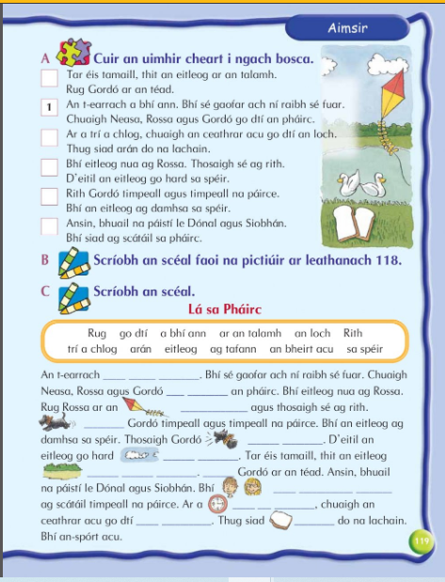

- What season was it? An T-….
- What kind of day was it? Bhí sé…
- Where did Neasa and Rossa go? Chuaigh
- What did Rossa have? Bhí
- What did Gordo do? Rith…
- 6. What were Donal and Siobhan doing? Bhí said…
- When did the four of them go to the lake? Ar a ___ a chlog …
- What did the children do at the lake ? Thug said arán…
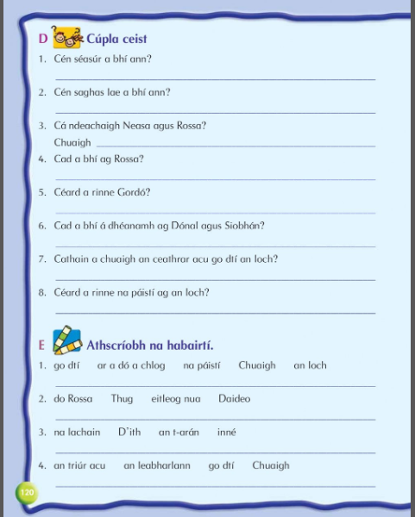

English
- List 33 spellings made fun
Reading Zone:
If you don’t have your book at home it can be found at:
- Go to www.folensonline.ie and tap Register
- Select Teacher
- Fill in a username, email and password
- For Roll Number use the code: Prim20
- Click Register
- Type in The Talking Horse (3rd class) or The Golden Harp (4th class) into the search bar

- 3rd class Unit 27 ‘’The Frog Prince’’
Use you Dictionary to look up words in red that you will find throughout the story (that you are unsure of)
Complete activities A-G based on the chapter (Do what you can)

- 4th class Unit 27 ‘’On Boaster’s Hill’’
- Use you Dictionary to look up words in red that you will find throughout the story (that you are unsure of)
- Complete activities A-G based on the chapter (Do what you can)

Maths
3rd class Area p161-165
https://my.cjfallon.ie/dashboard/student-resources ( in the boxes found when you arrive on this page click primary, 3rd class, maths, busy at maths, busy at maths 3 and underneath then you should see the tutorials)
Tutorials 100,101,102
4th class Area p159-162
https://my.cjfallon.ie/dashboard/student-resources ( in the boxes found when you arrive on this page click primary, 4th class, maths, busy at maths, busy at maths 4 and underneath then you should see the tutorials)
Tutorials 104,105,106
5th class Area and Perimeter
Figure it out 5 https://my.cjfallon.ie/preview/student/1312/63 p59-63
Busy at Maths 5 https://my.cjfallon.ie/preview/student/16884/120 p112-115

