Hello everyone I hope you are keeping well. We have had a few windy days that made playing outside and going for walks hard but let’s hope this week will be nicer. Please find attached some work for the week 25th-29th May. These are just suggestions. Do what you can and please don’t hesitate to send me an email if you have any questions.
Looking forward to hearing from you soon. Ms Tansey
Tanya.tansey3@gmail.com

English
- List 32 spellings made fun
Reading Zone:
If you don’t have your book at home it can be found at:
- Go to www.folensonline.ie and tap Register
- Select Teacher
- Fill in a username, email and password
- For Roll Number use the code: Prim20
- Click Register
- Type in The Talking Horse (3rd class) or The Golden Harp (4th class) into the search bar

- 3rd class Unit 25 ‘’Dad, Sam and Blacky’’
Use you Dictionary to look up words in red that you will find throughout the story (that you are unsure of)
Complete activities A-G based on the chapter (Do what you can)

- 4th class Unit 25 ‘’A Baker’s Dozen’’
- Use you Dictionary to look up words in red that you will find throughout the story (that you are unsure of)
- Complete activities A-G based on the chapter (Do what you can)

- Body Idioms (attached in email) pick 3 of your favourite and put them into new sentences.
Write a creative story of your choice. Here is a lovely site to give you some ideas http://www.scholastic.com/teachers/story-starters/
-online books https://www.readinga-z.com/ you can sign up for FREE trial and gain access to lots of books suitable for all ages
Online books type storyline online into google. (The link I tried to attach wouldn’t work)
Online Comics: https://dekkocomics.com
Oral Language www.literacyshed.com
These are short videos. Most of them are just visual. Discuss with your child what they think the video was about.

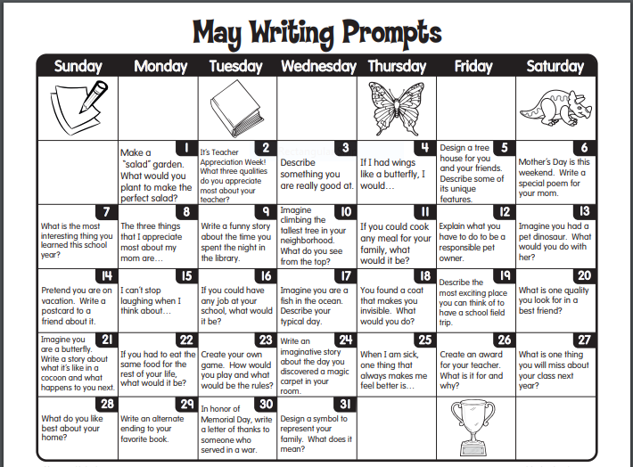

Gaeilge
Chapter 18 An Siopa Scoile (The school shop) p112-117
P115
1.Where were the children?
2.Who went to the shop?
3.What time did she go to the shop?
4.Who was working in the shop?
5.What happened to Neasa’s ruler?
6.What did Neasa buy?
7. What price was it?
8.What change did she get?
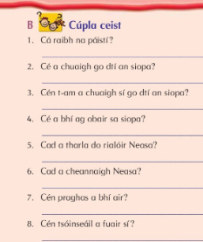

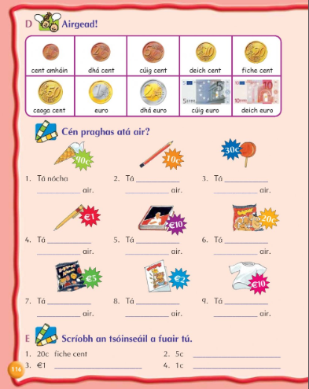
p116
1.nócha cent
2.deich cent
3.triocha cent
4.euro
5.deich euro
6. fiche cent
7.cúig euro
8.dhá euro
9. deich euro

Maths
Use the kitchen weighing scales to help and measure if have one.
Help to measure and weigh if adults at home are baking.
3rd class weight p156- 160
https://my.cjfallon.ie/dashboard/student-resources ( in the boxes found when you arrive on this page click primary, 3rd class, maths, busy at maths, busy at maths 3 and underneath then you should see the tutorials)
Tutorials 96,97,98,99
4th class weight p153-158
https://my.cjfallon.ie/dashboard/student-resources ( in the boxes found when you arrive on this page click primary, 3rd class, maths, busy at maths, busy at maths 3 and underneath then you should see the tutorials)
Tutorials 101,102,103
5th class figure it out 5 https://my.cjfallon.ie/preview/student/1312/3 Weight p75-79 Busy at maths 5 https://my.cjfallon.ie/preview/student/16884/7 p135-139
https://my.cjfallon.ie/dashboard/student-resources ( in the boxes found when you arrive on this page click primary, 5th class, maths, busy at maths, busy at maths 5 and underneath then you should see the tutorials)
Tutorial 82

The old recipe riddle (Attached)
Converting grams and kilograms (attached)

Maths websites

https://www.coolmath4kids.com/

STEM (Science, Technology, Engineering and Maths)
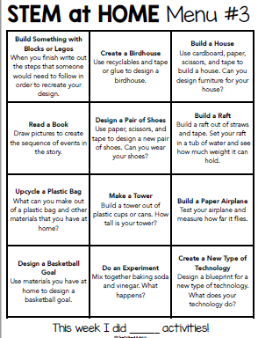

SESE
How to make a kite https://learning-center.homesciencetools.com/article/flight-and-kite-science/

Geography
Spain fact file (attached)
France fact file (attached)

Project
Find some information on an animal of your choice. Here are some resources to help you. Your headings could include

Habitat | Description of animal | Diet | Interesting facts | A picture of your animal (drawn or taken from other sources)

https://www.rte.ie/learn/2020/0426/1134893-were-going-to-the-zoo-zoo-zoo/
https://kids.nationalgeographic.com/
https://www.kidzone.ws/animals/
https://seaworld.org/animal-info/Animal-Bytes/index.htm/
https://www.dublinzoo.ie/animals/our-animals/

PE
YOGA (Cosmic Kids Youtube)
GAA Skills https://learning.gaa.ie/gogamesskillchallenges
Challenges https://learning.gaa.ie/sites/default/files/Issue%205%20Senior%20Classes.pdf

Art
Draw a picture of your real life hero.
The following website has some examples of other children’s work
https://drawourheroes.ie/

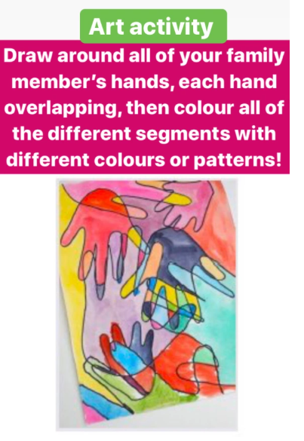

Mindfulness colouring sheets (sheets attached)

