Hello everyone. I hope you are all well and are enjoying the sunshine. Please find attached some work for the week April 27th- May 1st . These are just suggestions. Do what you can and please don’t hesitate to send me an email if you have any questions. I would be happy to help you or to hear what you have been up to. Thank you to everyone who sent in pictures of work last week. It was lovely to hear from you.
Looking forward to hearing from you soon. Ms Tansey
Tanya.tansey3@gmail.com

Week beginning 27th April 2020
English
- List 28 Spellings made fun.
- Finish the last chapter in Kensuke’s Kingdom.
- Dictionary work
Chapter 8 | Chapter 9
rummage | Cocoon
affliction | Reconciliation
probe | Trepidation
flotsam | Expounding
dowelling | Haunch
twine | sullen
canvas | Slink off
outrigger | Bemused
Grasp | Scuttle away
Condemnation | Reproach

Keep reading. You will learn more new words to add to your growing list of vocabulary. You can read books you already have or you can read some books online oxfordowl.co.uk

CHAPTER 8: EVERYONE DEAD IN NAGASAKI
After reading:
Write the 8 most important events in Kensuke’s life:

So why was Kensuke angry when Michael had made the fires?

How do you think that Kensuke FEELS when he sees the message in the bottle?

CHAPTER 9 THE NIGHT OF THE TURTLES

After reading:
Why do you think Kensuke has changed his mind about leaving the island? Find at least 3 pieces of EVIDENCE from the chapter.

KENSUKE’S THOUGHTS:

Maths – 3rd/4th class level:
3rd class chapter 24 Lines and angles p128-131
Please use the following link to help with lines and angles
https://my.cjfallon.ie/dashboard/student-resources ( in the boxes found when you arrive on this page click primary, 3rd class, maths, busy at maths, busy at maths 3 and underneath then you should see the tutorials)
tutorial 75, 76, 77 and 78 will help
4th class chapter 8 lines and angles p43-46
Please use the following link to help with lines and angles
https://my.cjfallon.ie/dashboard/student-resources ( in the boxes found when you arrive on this page click primary, 4th class, maths, busy at maths, busy at maths 4 and underneath then you should see the tutorials)
tutorial 30, 31 and 32 will help
5th class figure it out 5 lines and angles p38-41
https://my.cjfallon.ie/dashboard/student-resources ( in the boxes found when you arrive on this page click primary, 5th class, maths, figure it out, figure it out 5)
some tutorials that will help follow this link
https://my.cjfallon.ie/dashboard/student-resources ( in the boxes found when you arrive on this page click primary, 5th class, maths, busy at maths, busy at maths 5 and underneath then you should see the tutorials)
tutorials 23,24,25,26

Topmarks online (If you have access to internet and a device with internet access)
https://www.topmarks.co.uk/Search.aspx?q=angles

Gaeilge
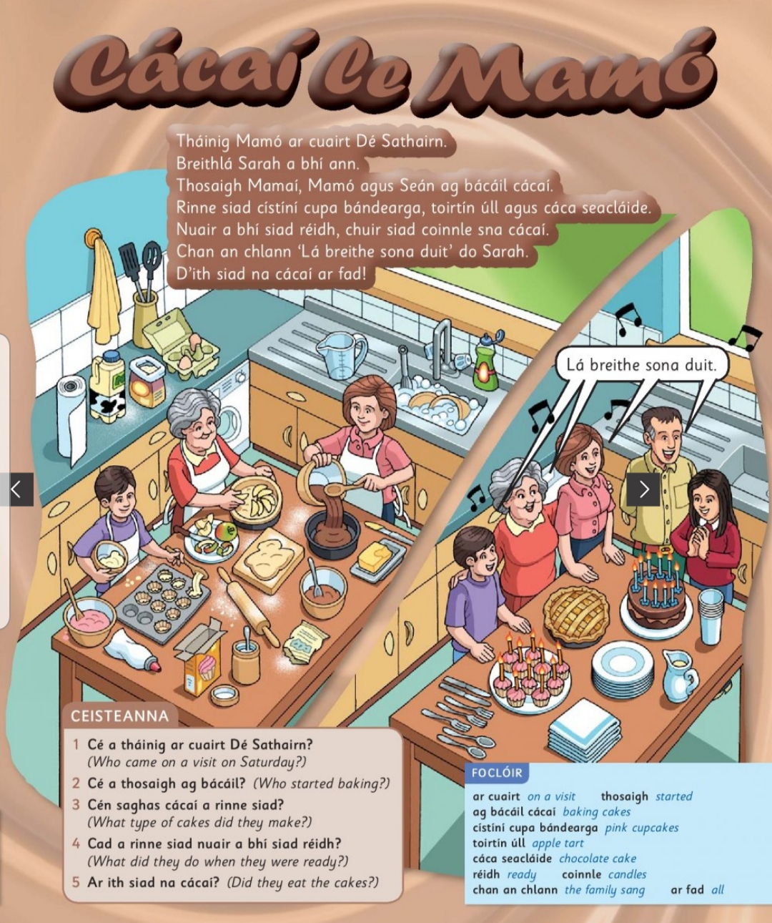

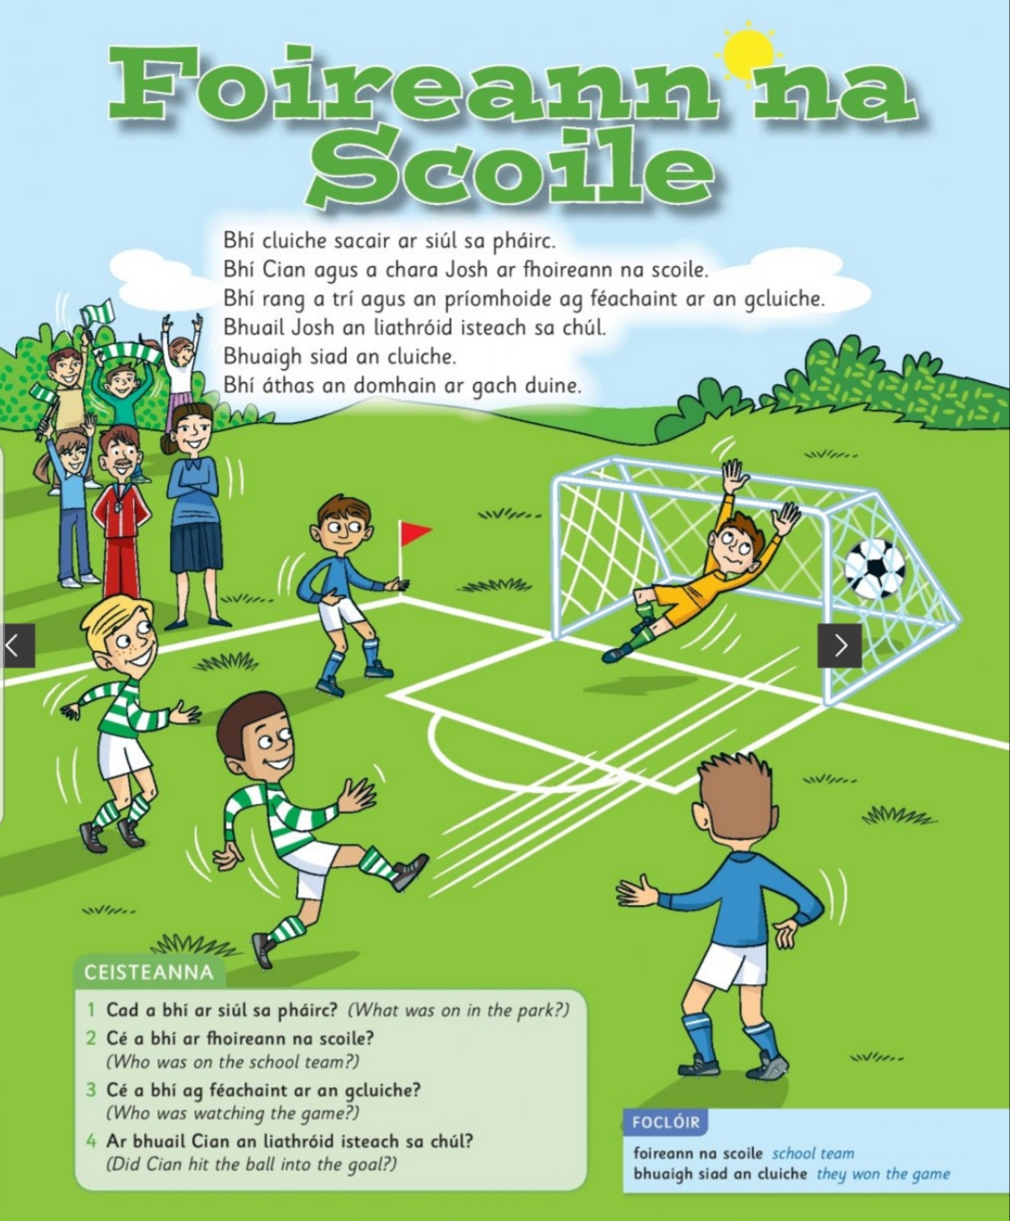

/
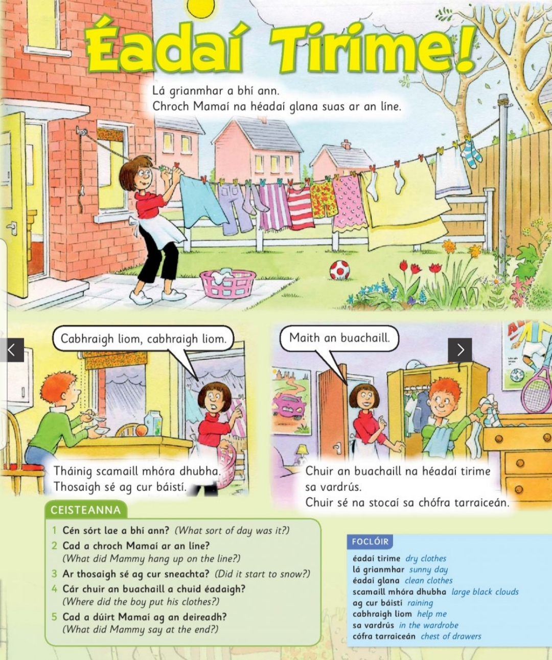

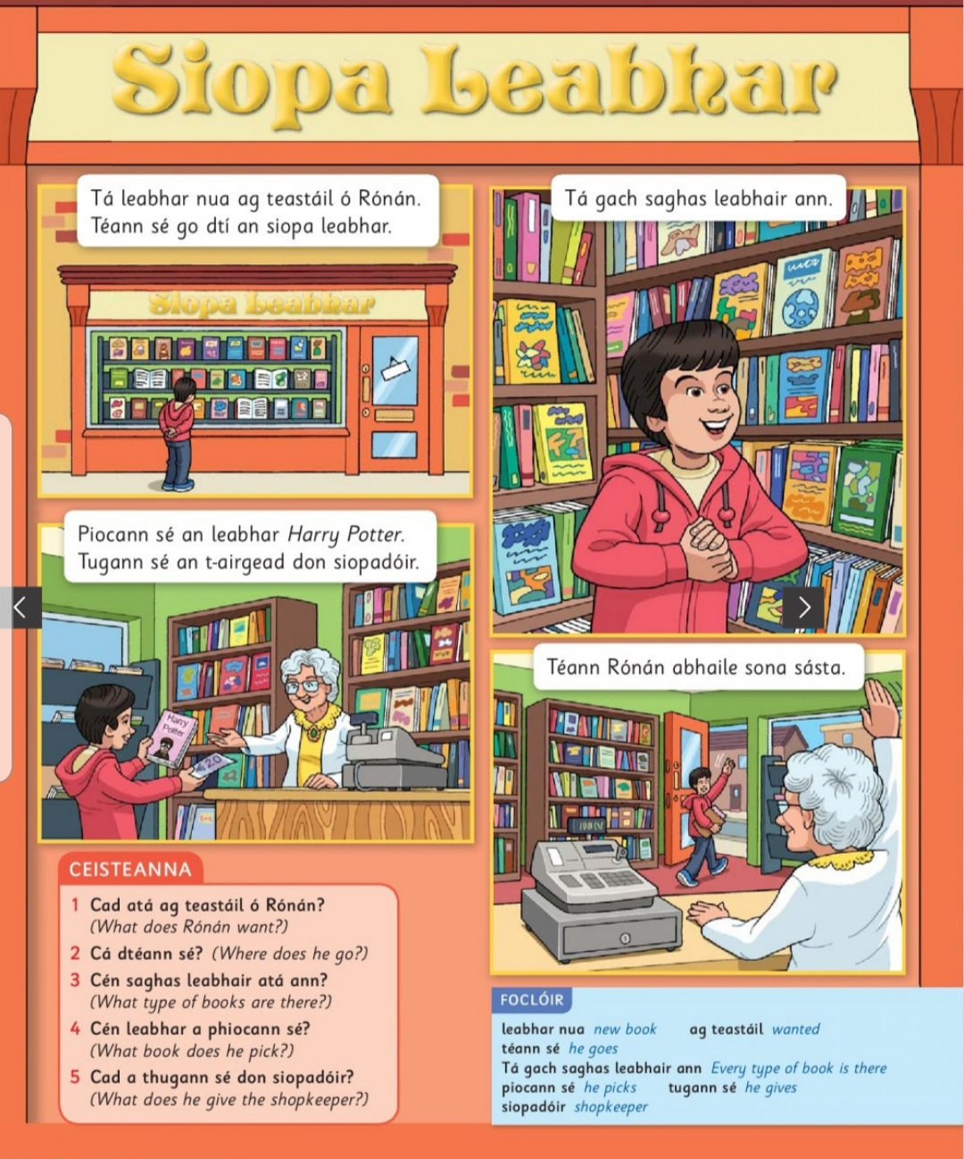

SESE
Plants and habitats
https://my.cjfallon.ie/preview/student/4145/20
Follow the link above. Read all about plants and habitats.
On page 22 there is a nice experiment. You will need some seeds. (Do not worry if you don’t have these). We can do the experiment in school another time.

-The Primary Planet, will be published as an online magazine from April onwards
. they will have some quizzes and activities that they will post on the website daily.

STEM challenge Build a bird feeder from recyclables.
Art
- Art hub for kids has some lovely drawing tutorials
https://www.youtube.com/user/ArtforKidsHub/videos?app=desktop

PE
-Youtube P.E. with Joe Wicks
-The 10 at 10 exercises are available on RTE junior
-Yoga for kids https://www.youtube.com/user/CosmicKidsYoga
-Go Noodle https://family.gonoodle.com/
-Music – Go to the Dabbledoo music website and enrol for free or follow the link below
https://dabbledoomusic.com/p/parents

-RTÉ Home School Hub is on RTÉ2 Monday to Friday at 11AM.
Additional bespoke activity sheets are available for each episode of RTÉ Home School Hub. These are available for each class group and can be downloaded in both Irish & English where appropriate at https://www.rte.ie/learn/

