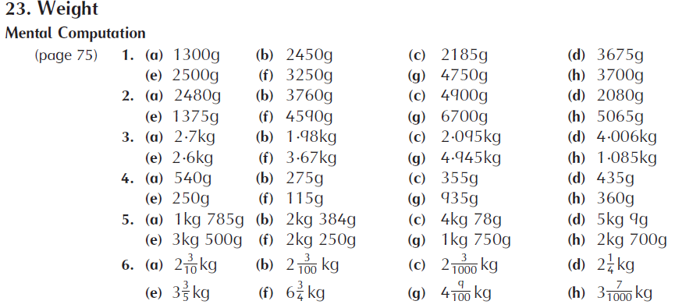
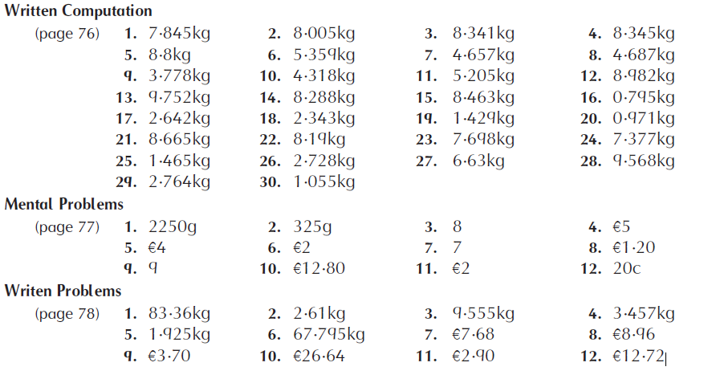

Busy at Maths 5
PAGE 135  (a) 20g, kitchen scales  (b) 600g, kitchen scales  (c) 2kg, spring balance  (d) 15g, kitchen scales  (e) 500kg, livestock scales  (f) 270g, kitchen scales  (g) 100g, kitchen scales  (h) 3,750kg, weigh bridge  (i) 25g, kitchen scales  (j) 350g, kitchen scales  Maths Fact: 55.2kg | PAGE 136  1.  (a) 9/1000 = 0.009kg  (b) 14/1000 = 0.014kg  (c) 3/1000 = 0.003kg  (d) 416/1000 =0.416kg  (e) 228/1000 = 0.228kg  (f) 67/1000 = 0.067kg  (g) 923/1000 = 0.923kg  (h) 503/1000 = 0.503kg  (i) 156/1000 = 0.156kg  (j) 830/1000 = 0.830kg  (k) 449/1000 = 0.449kg  2.  (a) 533/1000 = 533g  (b) 6/1000 = 6g  (c) 72/1000 = 72g  (d) 272/1000 = 272g  (e) 650/1000 = 650g  (f) 165/1000= 165g  (g) 810/1000 = 810g  (h) 10/1000 = 10g  (i) 384/1000 = 384g  (j) 700/1000 = 700g  (k) 990/1000 = 990g  3.  (a) 2,736g  (b) 6,259g  (c) 4,372g  (d) 3,257g  (e) 8,057g  (f) 5,418g  (g) 6,450g  (h) 3,300g  (i) 3,709g  (j) 8,731g  (k) 5,008g  4.  (a) 1.737kg  (b) 1.459kg  (c) 6.281kg  (d) 2.046kg  (e) 0.990kg  (f) 3.553kg  (g) 8.300kg  (h) 6.430kg  (i) 7.084kg  (j) 5.308kg  (k) 9.004kg  Maths Fact: 170kg | PAGE 137  1.  (a) 30.323kg  (b) 32.266kg  (c) 30.001kg  (d) 32.323kg  (e) 29.010kg  2.  (a) 5.909kg  (b) 17.880kg  (c) 2.088kg  (d) 8.989kg  (e) 2.776kg  (f) 1.796kg  (g) 5.598kg  (h) 2.868kg  3.  (a) 140.376kg  (b) 65.618kg  (c) 238.842kg  (d) 93.774kg  (e) 267.463kg  (f) 196.504kg  4.  (a) 7.114kg  (b) 3.588kg  (c) 8.037kg  (d) 2.687kg  (e) 4.506kg  5.  (a) 49.812kg  (b) 151.808kg  (c) 3.041kg  (d) 2.378kg  (e) 80,091kg  (f) 1.933kg  Maths Fact: 0.394kg | PAGE 138  1. 200g  2. 175g  3. 1.169kg  4. 3.818kg  5. 0.765kg  6. €4.31  7. 36.749kg  8. 66.115kg  9. 36.756kg  10. 752.982kg  11. 13.487kg  Maths Fact: 15kg | PAGE 139  1.  (a) €2.58  (b) €3.70  (c) €16.70  (d) €6.48  (e) €9.12  (f) €3.40  (g) €1.08  (h) €7.70  (i) €2.96  (j) €2.00  2. 202kg  Maths Fact: 2,724kg

