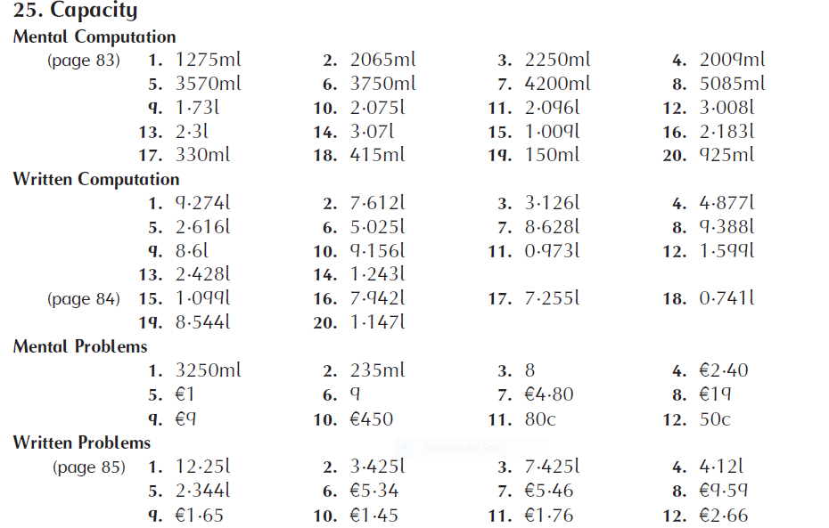

PAGE 170  1.  (a) 15ml  (b) 2l  (c) 10l  (d) 2 ½ l  (e) 1l  (f) 70l  (g) 500l  2.  (a) 1,250ml  (b) 1l 250ml  3.  (a) 4l  Maths Fact: 20  Challenge: (a) 4  (b) €10.02  (c) €9.13 | PAGE 171  1.  (a) 5/1000 = 0.005  (b) 18/1000 = 0.018  (c) 2/1000 = 0.002  (d) 75/1000 = 0.075  (e) 146/1000 = 0.146  (f) 420/1000 = 0.420  (g) 902/1000 = 0.902  (h) 700/1000 = 0.700  2.  (a) 3/1000 = 3ml  (b) 51/1000 = 51ml  (c) 4/1000 = 4ml  (d) 267/1000 = 267ml  (e) 3/100 = 30ml  (f) 68/100 = 680ml  (g) 104/1000 = 104ml  (h) 92/100 = 920ml  3.  (a) 4,159ml  (b) 5,750ml  (c) 6,258ml  (d) 25,703ml  (e) 16,030ml  (f) 7,372ml  (g) 9,290ml  (h) 2,200ml  4.  (a) 3.561l  (b) 4.247l  (c) 8.42l  (d) 2.049l  (e) 6.07l  (f) 0.319l  (g) 0.053l  (h) 2.264l  Maths Fact: 52 | PAGE 172  1.  (a) 700ml  (b) 60ml  (c) 90ml  (d) 750ml  (e) 75ml  3.  (a) 85ml  (b) 800ml  (c) 80ml  (d) 900ml  Maths Fact: (a) 500ml  (b) 0.5l | PAGE 173  1.  (a) 8.832l  (b) 8.355l  (c) 32.332l  (d) 24.551l  (e) 44.033l  2.  (a) 1.860l  (b) 2.965l  (c) 2.692l  (d) 3.815l  (e) 2.458l  3.  (a) 4.858l  (b) 6.233l  (c) 2.776l  (d) 4.655l  (e) 23.422l  4. 789.41l  5. 4.731l  6.  (a) 41.764l  (b) 102.464l  Maths Fact: 4 | PAGE 174  1.  (a) 21.735l  (b) 28.980l  (c) 38.640l  (d) 65.205l  (e) 91.770l  (f) 101.43l  (g) 140.070l  (h) 166.635l  2.  (a) 0.912l  (b) 0.608l  (c) 0.456l  (d) 0.304l  (e) 0.152l  3.  (a) €2.90  (b) €3.24  (c) €3.55  (d) €2.85  (e) €3.21  5. 1.5l  6.  (a) 73/100l  (b) 1,400ml  (c) 7.29l  (d) 0.054l  (e) 9 2/10l  (f) 8 ¾l  Maths Fact: 40l | PAGE 175  1.  (a) 1.888l  (b) 9l 841ml  (c) 0.797l  (d) 1l 635ml  (e) 20.101l  2.  (a) 5.4l  (b) 8.775l  (c) 31.725l  (d) 42.525l  3.  (a) 1.59l  (b) 1.06l  (c) 0.636l  (d) 0.265l  5.  (a) 1,720ml  (b) 1,400ml  (c) 7 ½ l  (d) 9 2/10l  6. 20ml  7. 0.125ml  8. 11,756l  9. €431.60  10.  (a) 84.12l  (b) 129.49l  Maths Fact: 2,379l

