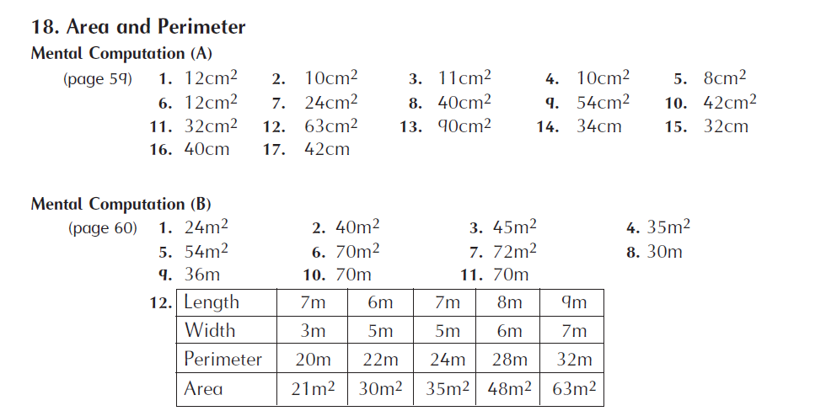
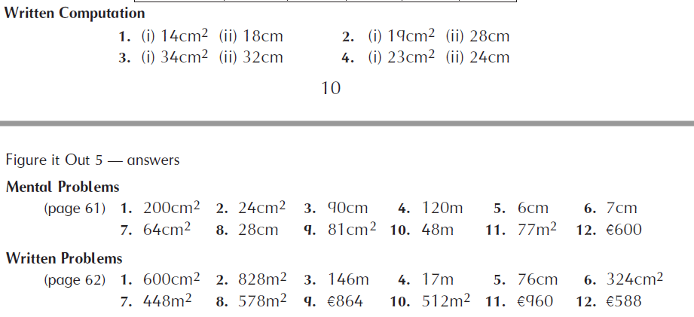

Busy at Maths 5
PAGE 112  1.  (a) cm2  (b) cm2  (c) m2  (d) cm2  (e) m2  (f) cm2  (g) m2  (h) m2  (i) cm2  (j) m2  2.  (a) 16cm2  (b) 18cm2  (c) 12cm2  (d) 22cm2  (e) 25cm2  (f) 13cm2  (g) 13cm2 | PAGE 113  1.  Head: 12cm2, 16cm;  Eye: 1cm2, 4cm;  Body: 40cm2, 28cm;  Tail: 3cm2, 8cm;  Leg: (x2), 6cm2, 16cm;  Whole dog: 61cm2, 56cm  3.  (a) (i) 36cm2  (ii) 12cm2  (iii) 18cm2  (b) (i) 16cm  (ii) 24cm  (c) 2/3  (d) square  (e) 1/3  4.  (i) (a) 14cm2  (b) 30cm  (ii) (a) 14cm2  (b) 18cm  (iii) (a) 11cm2  (b) 24cm  (iv) (a) 9cm2  (b) 20cm  (v) (a) 16cm2  (b) 24cm | PAGE 114  1.  (a) 12cm2  (b) 9cm2  (c) 12cm2  (d) 20cm2  (e) 15cm2  2.  (a) 10cm2  (b) 4cm2  (c) 54cm2  (d) 24cm2  (e) 24cm2  (f) 72cm2  3.  (a) 18cm2  (b) 14cm2  (c) 24cm2  (d) 18cm2 | PAGE 115  1.  (a)  Length: 4cm  Width: 2cm  Area: 8cm2  Perimeter: 12cm  (b)  Length: 3cm  Width: 3cm  Area: 9cm2  Perimeter: 12cm  (c)  Length: 5cm  Width: 4cm  Area: 20cm2  Perimeter: 18cm  (d)  Length: 4cm  Width: 3cm  Area: 12cm2  Perimeter: 14cm  2.  (a) 250m2  (b) 315cm2  (c) 456m2  (d) 126cm2  3.  (a) 76cm  (b) 361cm2  (c) 152cm  4.  (a) €483  (b) €17  5.  (a) 34m  (b) €238  (c) €1,056  (d) €444  Challenge: 64cm2

