Hello everyone,

I hope you are all doing well at home and were able to celebrate the bank holiday weekend in some way. Below is suggested work for the week 5th- 8th May. Again, do whatever you are able to do and please don’t hesitate to send me an email if you have any questions. For those of you who haven’t checked out https://www.theprimaryplanet.ie/ yet, there are some great, interesting activities and reading up there every day which I think you will enjoy.
Thank you to everyone who got in touch over the past couple of weeks, it was so nice to hear from you and see all the hard work you have been doing. It’s great to see so many of you helping out with jobs around the house and on the farm as well as developing new talents. Keep up the great work and continue getting lots of exercise and fresh air.

Looking forward to hearing from you all soon.

Arlene Gilhooly

agilhoolyschool@gmail.com

Literacy

Dictionary Work/Reading:
- I have attached Dictionary Work 3 for this week’s new vocabulary. You can complete it on Microsoft Word and send back to me.
- Keep up the reading every day! It is so important for developing your vocabulary and reading fluency as well as
- The following website has free Ebooks too https://home.oxfordowl.co.uk/books/free-ebooks/

Creative Writing:
Over the next few weeks you will be encouraged to write your own creative story, which can be about anything you like. The focus should be on the quality of your writing rather than the amount that you write. Your first task is to come up with the main character for your story using the worksheets provided to help you. (These are attached separately).

Reading Zone:
If you don’t have your book at home it can be found at:
- Go to www.folensonline.ie and tap Register
- Select Teacher
- Fill in a username, email and password
- For Roll Number use the code: Prim20
- Click Register

- 5th Class: Unit 21 “The Godfather”
Discuss the words in red and see if you can come up with synonyms (alternative words). Look up any words you are unsure of.
Complete activities A-G based on the chapter (whatever you are able to do)

- 6th Class: Unit 21 “Alien Visitors”
Discuss the words in red and see if you can come up with synonyms (alternative words). Look up any words you are unsure of.
Complete activities A-G based on the chapter (whatever you are able to do)

Maths
Area

Maths Book:
- 5th Class Chapter 21 Area Pg. 112-118 Online Tutorial 67-71
- 6th Class Chapter 24 Area Pg. 125-130 Online Tutorial 74-77

Online tutorials and games can be found on https://my.cjfallon.ie/dashboard/resources Class Busy at Maths Interactive . These will help explain new concepts and give you the chance to practice.

Area: Other Activities
Mark out a square metre using chalk or tape on the ground to get an idea what it looks like. This is written as 1m².

Can you find the area of the following?
-The surface of your kitchen table
-Your kitchen/living room/bedroom
-Your garden
-Your front door

Tables/Games:
Tables are still as important as ever. Keep up the great work. Here are some websites to help.
https://www.topmarks.co.uk/maths-games/daily10
https://www.topmarks.co.uk/times-tables/coconut-multiples
https://www.topmarks.co.uk/maths-games/hit-the-button
https://www.topmarks.co.uk/maths-games/daily10
http://www.primaryhomeworkhelp.co.uk/maths/countdown/index.htm
http://irishprimaryteacher.ie/times-tables-jenga/

There are mental maths activities available every day on https://www.theprimaryplanet.ie/. You can post your answers in the comment box and they will be corrected for you!

Irish

Bun go Barr:
- Unit 15: Maistín Mór (Big Bully). If you don’t have your book it can be found online at https://my.cjfallon.ie/dashboard/resources 5th class Bun go Barr Online Book

- There is an interactive activity to accompany this lesson found at the above website. Just go to ‘Interactive’ instead of Online Book and Ceacht 15. See if you can translate the sentences orally.

- Read Pg. 92 and translate as much as possible
- Complete Activity B1-5. Here are the translations as well as first verb.
1. Where were the children at lunch time? Bhí….
2. What did the teacher hear? Chuala…
3. Was Neasa’s nose bleeding? Ní raibh…
4. Who was shaking with fear? Bhí..
5. Did Dónal start crying? Thosaigh..

- Activity C: Finish the sentences
Bhuail=hit
Thosaigh=started
Ghoid=Stole
Leag=knocked
Stróic=Ripped
This=Fell

- Activity D: Tá súil agam nach raibh sibh…I hope that ye weren’t…
Ag súgradh sa bháisteach=playing in the rain
Ag magadh faoin múínteoir=Mocking the teacher
Ag pleidhcíócht=messing
Ag ithe sa leabharlann=Eating in the library
Ag féachaint ar an teilfiís=Watching the T.V
Ag caint sa séipéal=Talking in the Church

- Activity K: Spot the differences
Try your best to say them in Irish

Reading:
Eleathanach is a weekly “current affairs” newsletter aimed at pupils from 5th class up to Junior Cert.
https://www.maynoothuniversity.ie/froebel-department-primary-and-early-childhood-education/eleathanach
Click on the above link and then go to eleathanach na seachtaine. Have a read through it and see if you can understand the general idea. (Some vocabulary will be tricky)

Song
Continue to practice your Kodaline song https://www.youtube.com/watch?v=ZFzFTR33z2k

History

1916 Easter Rising
- Discuss with a family member ten facts that you learned about 1916. Continue working through the worksheets provided over the last couple of weeks.

Extra Websites to support 1916
- https://kids.kiddle.co/Easter_Rising
- https://www.scoilnet.ie/primary/theme-pages/history/easter-rising-1916/

*Keep all of your 1916 work together. You can put it all into a project if you like.

Geography/Art

European Flags:
You have learned about European Countries and their capitals, see if you can name the flags through this online game.
https://world-geography-games.com/flags_europe/index.html

Garden Art:
With your parents’ permission, gather some natural items from around the garden such as leaves, petals, twigs, pebbles, berries and see what you can create. Feel free to take a picture and send it into me. Here is an example below. As an extension activity see if you are able to name the trees/flowers that your leaves/petals have fallen from.

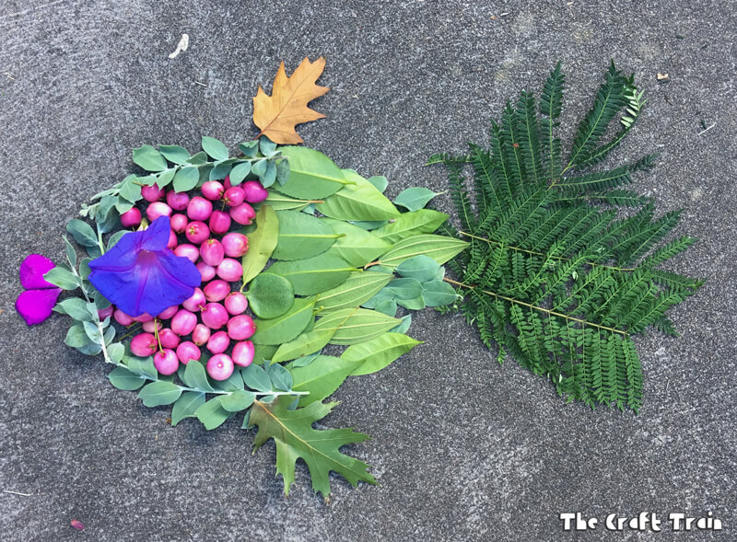

Science

Light:
- Following on from your Unit on Light over the past fortnight, try out of one these experiments from primary science.
Primaryscience https://www.sfi.ie/engagement/discover-primary-science-and-maths/activities-search/index.xml#result Click on light and class level and choose one of the experiments to do at home.

Primary Planet:
- The Primary Planet, will be published as an online magazine from April onwards, while related exercises, quizzes and activities will be posted on the website daily. This, we hope, will help inform, engage and inspire our pupils through these difficult times.
https://www.theprimaryplanet.ie/. Check it out, I think a lot of you will really enjoy it.

Other Activities:
https://hourofcode.com/ie/learn Lots of free coding activities for those who enjoy Computer Science
https://www.odlums.ie/ For those who enjoy baking

P.E
- Live 30 minute session designed for kids every day at 9am with Joe Wicks https://www.youtube.com/watch?v=K6r99N3kXME
- Relaxation: Below is a YouTube link to Cosmic Kids Yoga which is good for helping you relax and stay focused during a hectic day. Give it a go, it may help you clear your head and stay more focused on your work.
https://www.youtube.com/results?search_query=cosmic+kids+yoga
- Shine Dance Fitness: These have some great dance routines for those of you who like to keep fit through dancing https://www.youtube.com/channel/UCFSpQu4Ha82Cwfu5KJhl5fQ
- Good for 5 minute movement breaks throughout the day
https://www.youtube.com/results?search_query=5+minute+move+kids
- Keep getting lots of exercise and practicing all of your own unique talents. Make the most of any bit of sunshine.

Music
I came across this website to help you make your own music (and even writing and singing songs) It’s really easy to use. You will create your own music in no time. https://musiclab.chromeexperiments.com/Song-Maker/

Other activities/ideas:
https://www.twinkl.ie/resource/t-d-032-stem-challenge-cards
https://www.twinkl.ie/resource/t2-t-16815-ks2-take-it-outside-stem-teaching-ideas

RTE2 are running a TV programme from 11am-12pm Monday to Friday, which is aimed at 1st to 6th class pupils. Also available from https://www.rte.ie/player/
Cúla4 ar Scoil are running lessons through Irish on TG4 at 10am every morning.

Suggested Timetable
Monday | Tuesday | Wednesday | Thursday | Friday
BANK  HOLIDAY | P.E (Joe Wicks live on Youtube) | P.E (Joe Wicks live on Youtube) | P.E (Joe Wicks live on Youtube) | P.E (Joe Wicks live on Youtube)
 | Irish | Irish | Irish | Irish
 | Maths | Maths | Maths | Maths
 | English | English | English | English
 | Geography | Science | Art | History

