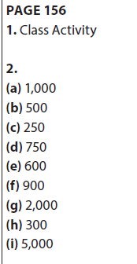 | 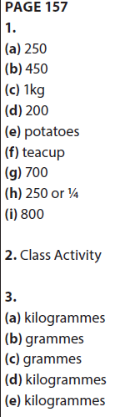 | 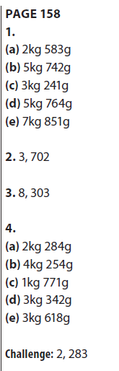 | PAGE 159  1.  (a) 500 + 500  (b) 250 + 250 + 250 + 250  (c) 500 + 200 + 100 + 100 +  100  (d) 200 + 100 + 100 + 100  (e) 200 + 50  (f) 100 + 100 + 20 + 20 + 10  2.  (a) 8, 202  (b) 8, 924  (c) 1, 654  (d) 1  (e) 17, 126 | PAGE 160  1. €9∙80  2. 1∙60  3. 6∙60  4. 36  5. 330  6. 705  7. +  8. ÷  9. 1st May  10. 2, 15  11. 1,000  12. 250  13. 5  14. 9  15. 62  16. 100  17. 31  18. 7, 6  19. 94∙9  20. 24

