Hello everyone. I hope you are all well and are enjoying the sunshine. Please find attached some work for the week 11th-15th May. These are just suggestions. Do what you can and please don’t hesitate to send me an email if you have any questions. I was delighted to receive some pictures from you to see that you are working hard doing school work, making junk art, baking, gardening, farming, working on the bog and going on walks.
Looking forward to hearing from you soon. Ms Tansey
Tanya.tansey3@gmail.com

Just a reminder Could you please keep your child’s library book safe (Kensuke’s Kingdom) as it will have to be returned Roscommon library when we return to school. Thank you

English
List 30 spellings made fun
Please find attached a reading passage for 3rd (Horrid Henry) and 4th (Follow the rules).
Read the passage and answer the questions in your copy.
Idioms (attached) Building Idioms

1m=100cm
2m=200cm
3m=300cm
4m=400cm
5m=500cm
Maths
3rd class chapter 22 length p 119-122
https://my.cjfallon.ie/dashboard/student-resources ( in the boxes found when you arrive on this page click primary, 3rd class, maths, busy at maths, busy at maths 3 and underneath then you should see the tutorials)
Tutorial 67,68,69, 70,71,72
See workings attached

4th class chapter 22 length p111-114
https://my.cjfallon.ie/dashboard/student-resources ( in the boxes found when you arrive on this page click primary, 4th class, maths, busy at maths, busy at maths 4 and underneath then you should see the tutorials)
Tutorial 73,74,75,76,77,78
See workings attached
5th class figure it out 5 p68-72
https://my.cjfallon.ie/preview/student/1312/72

Gaeilge
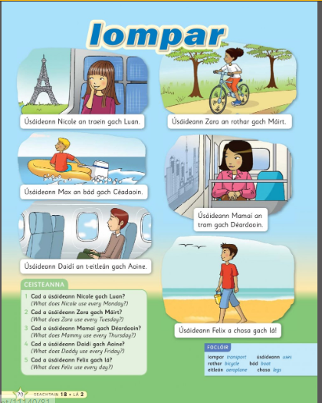
Audio link http://data.cjfallon.ie/audio/LeighsaBhaile-C-p70.mp3

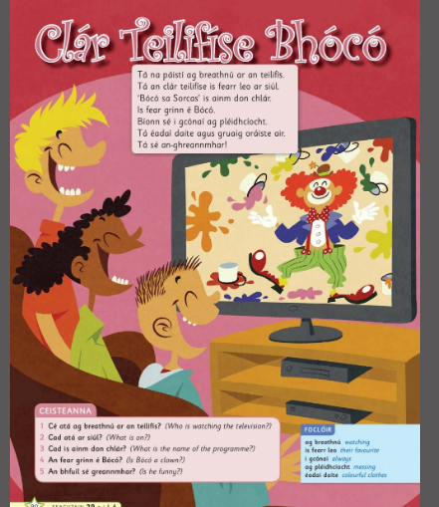
Audio link http://data.cjfallon.ie/audio/LeighsaBhaile-C-p80.mp3
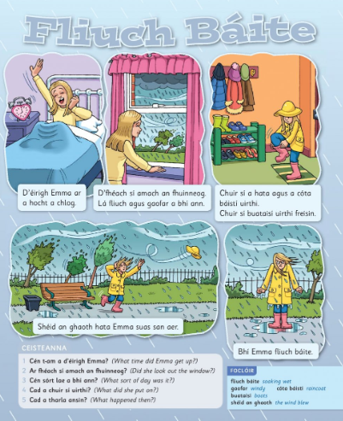
Audio Link http://data.cjfallon.ie/audio/LeighsaBhaile-C-p100.mp3
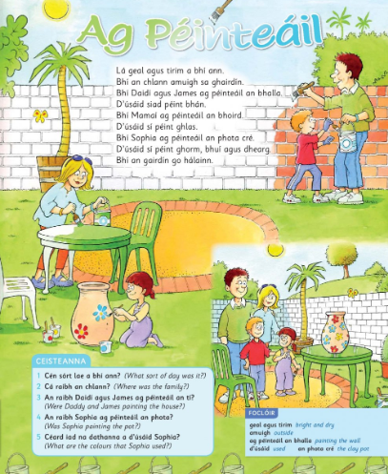
Audio link http://data.cjfallon.ie/audio/LeighsaBhaile-C-p107.mp3

SESE
Geography
Mountains of Ireland (sheet attached)
Rivers of Ireland (sheet attached)
Italy fact file (sheet attached)
Science
Heat
https://my.cjfallon.ie/preview/student/4145/102
There are some lovely experiments in the above link including Design and make a mini greenhouse
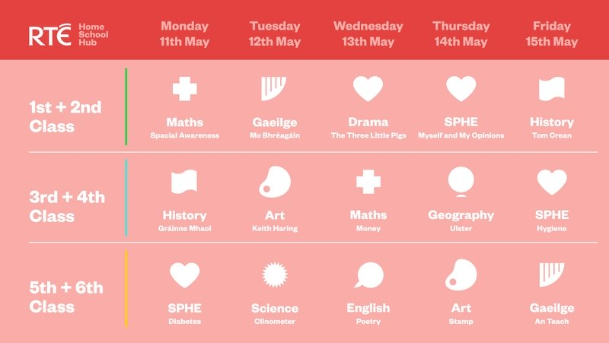

Other ideas
-Oxford owl- ebooks for all ages and levels
-oxfordowl.co.uk
-Music – Go to the Dabbledoo music website and enrol for free or follow the link below
https://dabbledoomusic.com/p/parents

